name of the article (style: juniorstav_title)

First name and last name of main (correspondent) author*,1, First and last name of other author1, First and last name of other author2 (style Juniorstav_Authors)

*Email address of the main/correspondent author (style Juniorstav _Address) (not required but recommended - if you do not want to give your email address, delete the asterisk next to your name and delete this line)

1Address of the author´s university or organization; or author´s address if he does not represent any organization; if multiple authors have the same address, write only once (style Juniorstav _Address)

2Address of the author´s university or organization; or author´s address if he does not represent any organization; if multiple authors have the same address, write only once.

Abstract (for the abstract and keywords use the style Juniorstav_ABS_KEY)

The abstract should correspond to the content of the article. It should briefly summarise the most important points of the paper. The maximum length is 500 characters (including spaces).

For the first and other paragraphs use the formatting style Juniorstav_Bodytext. (The use of styles is explained later in the text in the Styles section.)

Keywords

A maximum of 5 characteristic words. Use the formatting style Juniorstav Bodytext_EN. Start the first word with a capital letter. Separate each keyword with a comma. Don't put a full stop after the last word.

1 INTRODUCTION (style: juniorstav_section)

Specify the objective of the article clearly - the problem or task dealt with, and the context, use and importance of the whole research, as well as the motivation for conducting it. Describe the issues you want to cover and the hypotheses you will try to verify, and give a brief description of the proposed approach and experiments carried out. Start the first paragraph of the new section without indenting the paragraph (Juniorstav_Bodytext).

After the introduction, divide the article into clearly defined and numbered sections.

The maximum length of the article (including Figures, Tables, References and Abstract) is 10 pages. The minimum required article length is 4 pages. The structure of the article must follow the template; these sections are mandatory:

* Introduction
* Discussion
* Conclusion

However, if it is background research, keep the structure adequately. Please follow typographic principles, notably the following:

* The date should be written in the format DD/MM/YYYY, for example, 28/01/2024.
* The symbol for an apostrophe can be typed either using an English keyboard or with Alt + 0146 on Windows, or Option + J on iOS.
* Ordinal numbers, square meters, and cubic meters are written with superscripts, e.g., 7th, m², and m³.
* Large numbers use a comma to separate thousands, e.g., 1,000,000, while decimal numbers use a dot, e.g., 3.14.
* Currencies are placed before the number, e.g., CZK 2,000.

LITERARY OVERVIEW/DESCRIPTION OF THE PRESENT STATE

Provide references for other relevant articles. Compare methods with already published approaches. This part may also include theory, background information and calculations that have extended and refined the body of theoretical knowledge in this area.

After the introduction, divide the article into clearly defined and numbered sections.

Subsection (Style: Juniorstav_SubSection)

Individual subsections will not be numbered if you use them. The subsection name will be in the Juniorstav_SubSection format. The same rules apply to text. For the first and other paragraphs, use the formatting style Juniorstav_Bodytext.

References (Style: Juniorstav_SubSection) – EN ISO 690

The References section should provide references for relevant publications. For example, scientific articles and journals, research reports, or technical sheets and standards. Websites such as Wikipedia are not considered relevant sources. If possible, always cite the source document where the information is given.

Citations are to be numbered sequentially in the text using a number in square brackets, e.g. [2]. All such numbered citations must correspond to a listed source in the References section. The number in square brackets is included in the same sentence as the citation, and any punctuation (full stops, etc.) must come after it (e.g. [2].). If you cite multiple sources, separate them with a comma like this [1], [2]. Do not refer to multiple sources in this manner: [1-3], use [1], [2], [3].

The list of all references should be placed at the end of the article. All of the sources used in the text must be listed there, and all of the sources listed at the end of the article must be cited in the text, with a number in square brackets that is identical to their number in the References section. Non-public results and personal documentation are not to be listed in the References section.

2 METHODOLOGY (style: juniorstav_section)

In this section, please provide details on the methodology that was used to achieve the results of your research. The workflow should be described in this section of the article, whether it involved performing experiments, modelling or theoretical calculations. For example, there could be description of samples and test sets for experimental studies, or a description of the program and work process used in modelling or the derivation of calculations and assumptions. The methodology should be described in a manner that answers questions about the experimental methods, such as how measurements or calculations were performed, or how data were analysed. You can take inspiration from the following structure:

1. Description of the material or structure that is the subject of the research,

2. Explanation of the method of material preparation,

3. How the measurements were carried out and what calculations were performed,

4. How data analyses were performed.

The writing should be precise, clear and in the past tense. It is not appropriate to use extensive compound sentences or to describe unimportant details.

3 RESULTS (style: juniorstav_section)

This section should contain objectively presented results without their interpretation, which belongs in the next section. It is advisable to use comprehensible Tables and Figures. The presentation of the results should be brief and concise. Do not use long sentences.

Formatting styles (Style: Juniorstav_SubSection)

To view all formatting styles, we recommend that you view the sidebar, which you can find by clicking on the icon (see Fig. 1). The individual set styles have been prepared for use with the template. Please use them, as their goal is to obtain a uniform appearance for the text. Do not change the font, font size, alignment, etc. (This year, classic toolbar editing is no longer blocked. The unlocking of the template is primarily to enable the easier entry of upper and lower indices, italics, or possibly bold text.) There are also defined styles for using bold, italic, superscript and subscript. When to use which style is indicated in the template. If you want to change a part of the text to a different style, mark it and then click on the appropriate style (indexes for variables, etc.).

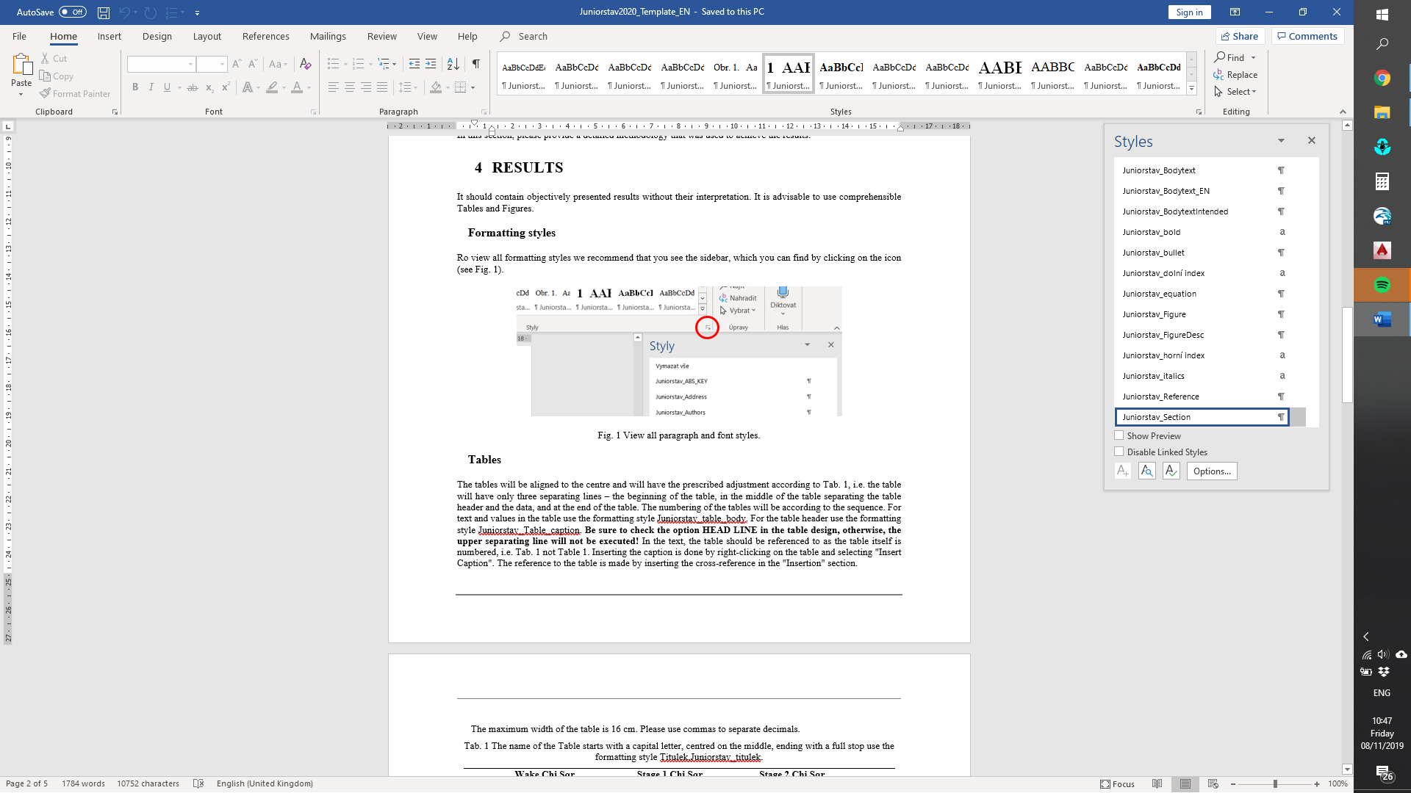

Fig. 1 View all paragraph and font styles.

Tables (Style: Juniorstav_SubSection)

Tables must be aligned to the centre and have the prescribed adjustment according to Tab. 1, i.e. the table will have only three separating lines – at the beginning of the table, in the middle of the table separating the table header from the data, and at the end of the table. The numbering of the tables must be sequential – Tab. 1, Tab. 2, etc. Use the formatting style Juniorstav_table_body for the text and values in the table. Use the formatting style Juniorstav_Table_caption for the table header. Be sure to check the option HEAD LINE in the table design, otherwise the upper separating line will not be executed! In the text, the table should be referred to according to the stated number of the table and using the abbreviation ‘Tab’, i.e. Tab. 1 not Table 1. All tables should be cited at the appropriate place in the text. The caption is inserted by right-clicking on the table and selecting "Insert Caption". The reference to the table is made by inserting the cross-reference in the "Insertion" section.

The maximum width of the table is 16 cm. Use a decimal point, not a comma, in decimal numbers (e.g. 3.14159). You can use the sample table and modify it for your needs or copy it to preserve the required formatting.

Tab. The name of the Table starts with a capital letter, is centred on the middle, and ends in a full stop. Use the formatting style Juniorstav_Caption.

|  |  |  |  |  |  |  |
| --- | --- | --- | --- | --- | --- | --- |
|  | Wake Chi Sqr. (N=15, df=1) | p | Stage 1 Chi Sqr. (N=15, df=1) | p | Stage 2 Chi Sqr. (N=15, df=1) | p |
| F3 | 1.143a | 0.285b | 0.286 | 0.593 | 0.286 | 0.593 |
| Fz | 1.143 | 0.285 | 0.067 | 0.796 | 0.067 | 0.796 |
| C4 | 2.571 | 0.109 | 0.600 | 0.439 | 1.667 | 0.197 |

Figures (Style: Juniorstav_SubSection)

Figures should use the formatting style Juniorstav_Figure. The text wrapping should be up and down. The name of the figure must be under the figure itself and end with a period. The numbering of figures should be sequential – Fig. 1, Fig. 2, etc., and they should be referred to in the text in the same manner – Fig. 1 not Figure 1. The author should try to make the best use of space - white margins should be the smallest possible, the size of the text inside the figure should be the same size as the surrounding text, and all information in the figure should be legible. Avoid using overly thin lines, as there may be a problem printing them (the optimal line thickness should be at least 0.25 pt). To insert a caption, right-click on the figure and select "Insert Caption". The link to the figure is made by inserting a cross-reference in the "Insertion" section. The maximum figure size is 15x15 cm. Resolution 300 dpi. Picture format should be .jpg or .png. If you want to insert multiple images side by side, it is convenient to place them in a table without visible borders. Alternatively, label them a), b), etc., and refer to them in the same way in a common caption.

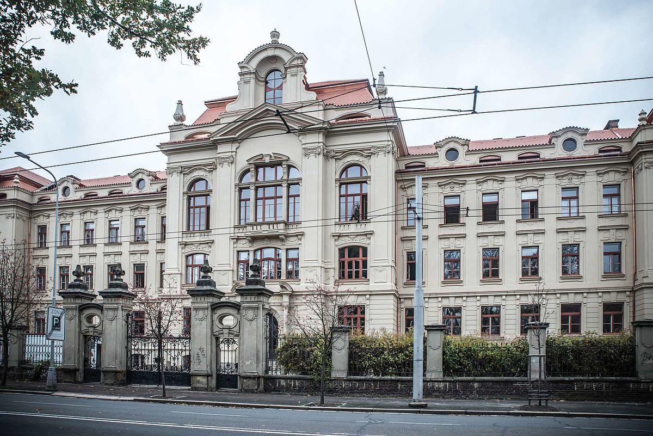

Fig. 2 The title should begin with a capital letter, be centred on the middle of the page, end with a full stop, and use the formatting style Juniorstav_Caption.

Graphs (Style: Juniorstav_SubSection)

Insert graphs into the text as figures, not graphs. Insertion requirements are described in the Figures section. The description of the graph should be, for example, Fig. 2, not Graph 2. All graphs and figures should be cited at the appropriate place in the text.

Bullets (Style: Juniorstav_SubSection)

Bullets in the text:

* For writing bulleted lists use the formatting style Juniorstav_bullet

Additional text after the bullets should be written in the formatting style Juniorstav_Bodytext.

Formulas (Style: Juniorstav_SubSection)

Formulas should be created in Office Math ML (1) or MS Equation Editor 3.0 (2). If you use Office Math ML, tick the LaTeX format entry in equation editing. The size of the text should match the size of the document text. Each equation should be numbered sequentially, with the number in brackets at the end of the line. Write the equation in the two-column table. The table takes up the full width of the page - the first cell has a column width of 15.3 cm, while the second cell has a column width of 0.79 cm. The text will be aligned centre / centre.

|  |  |
| --- | --- |
| $$R_{s}=\prod_{j=1}^{m}{\left[1-\prod_{i=1}^{k}{(1-R_{ji}})\right]}$$ | (1) |
|  | (2) |

where Zx is … after the formula, all variables should be listed in the sentence (not bullets!), including units (e.g. v is the speed in km/h). Write the variables mentioned in the text in italics – for writing in italics use the formatting style Juniorstav_Italics, for subscript use Juniorstav_subscript and for superscript use Juniorstav_superscript.

If a new paragraph begins after the formula, use the formatting style Juniorstav_Bodytext for it.

Type characters and spaces (Style: Juniorstav_SubSection)

For multiplication do not use the characters x [eks] or . (dot), use the math symbol × or · (middle dot). (You can use ASCII codes to write these characters: × = Alt+0215, · = Alt+0183). Always use a space (Shift+Ctrl+Space) to separate math symbols from numbers or text, e.g. 105 × 105 mm, or 1 : 2 : 4.

Characters should be written with spaces (Shift+Ctrl+Space) for addition, subtraction, multiplication and division in mathematical operations and also in ratios and dimensions, e.g. 3 + 5 - 2 = 6, 20 × 5 = 100, etc.

If the + or - sign is used to show a positive or negative value for a number, it is placed adjacent to a number without a space: +24 °C, −1 °C. Exponents and indices should also be written without a space: 5³, 10 − ², n1, n2…

To write indexes use the formatting styles Juniorstav_DOWN index and Juniorstav_UP index.

Abbreviations for units are to be separated from the numerical value they follow by a space (Shift+Ctrl+Space), e.g. 10 ha = 10 hectares, 3 kg = 3 kilograms, 14 % = 14 percent, § 9 = paragraph 9, 100 kWh = 100 kilowatt hours, speed 50 km/h = 50 kilometres per hour, density 5 g.m−³ = 5 grams per cubic meter, temperature 12–15 °C = 12 to 15 degrees Celsius.

If you want to use *italics* or highlight the text in bold, use the style Juniorstav_italics or Juniorstav_bold, but we recommend using these as little as possible.

4 DISCUSSION (style juniorstav_section)

This section contains interpretations of the results obtained, which should be in the context of other published papers. Within it, answer the questions raised, or comment on hypotheses. All conclusions should be based on the results achieved, i.e. the interpretation of values from tables, graphs or the results of experiments. Discuss any limitations to your research, or speculate about surprising results, especially if they differ from those previously published.

5 conclusion (style: juniorstav_section)

This section should contain a summary of the main results of the research in the context of the whole issue (the studied area and previously achieved results).

* The conclusion should be approximately 250 words long,
* It provides a brief summary of the results achieved,
* It is useful to summarise them like this as a bulleted list,
* It should contain answers to the following questions: Did the results meet your expectations, were the hypotheses confirmed, did you answer all the questions raised?
* How did your research contribute to explorations of the issue and to existing knowledge in the studied area? Etc.

What should the next research steps be? The main findings and results of the research should be reiterated. It can also be mentioned that the results obtained can serve as a basis for further research.

Acknowledgements (Style: Juniorstav_SubSection)

This section should contain an indication of the source of research funding, such as specific university research or grants.

References (Style Juniorstav_SubSection)

1. Reference no. 1 (all references according to **EN ISO 690)**
2. References should be listed in the text chronologically (sequentially) [1] [2] [3] …..
3. Self-citation: maximum **10%** of references
4. A minimum of 5 references is required, with 10 or more being recommended

**ISO 690 citation examples after the September 2023 update**

|  |  |
| --- | --- |
| **TEMPLATE** | **CREATOR/CREATORS. Title: subtitle. Edition order. Edition (optional). Place of publication: publisher, year of publication. ISBN. (optional DOI/ISSN).** |
| Printed BOOK | 1. WHITEHOUSE, D. J. Handbook of surface and nanometrology. 2nd ed. Boca Raton: CRC Press, c2011. ISBN 978-1-4200-8201-2. |
| Digital BOOK | 1. RAMALHO, Luciano. Fluent Python. Beijing: O'Reilly, 2015. ISBN 978-1-491-94600-8. Available at: http://search.ebscohost.com/login.aspx?direct=true&scope=site&db=nlebk&AN=1046596 |
| Electronic BOOK | 1. LECH, Richard**.**Fundamental principles of engineering nanometrology. Online, PDF. Oxford: Elsevier, 2010. ISBN 978-0-08-096454-6. Available at: ScienceDirect, <https://doi.org/10.1016/C2009-0-20339-4> [Accessed 09/06/2021]. |
| Chapter In book | 1. LONKA, Kirsti. Helping doctoral students to finish their theses. In: BJÖRK, Lennart, Gerd BRÄUER, Lotte REINECKER and Peter Stray JÖRGENSEN, eds. Teaching academic writing in European higher education. Dordrecht: Kluwer Academic Publ., 2003, pp. 113–131. ISBN 1-4020-1208-X. |
| Chapter In electronic book | 1. DEMAY, Y. Computation of 2D viscoelastic flowsfor a differential constitutive equation. In: PIAU, J-M. and J-F. AGASSANT, eds. Rheology for polymer melt processing [online]. Oxford: Elsevier, 2011, pp. 237–255. [Accessed 09/06/2021]. ISBN 9780444822369. Available at: http://www.sciencedirect.com/science/article/pii/S0169310796800098 |
| Printed Article magazine | 1. MANSOURI, Majdi, Quachani ILHAM, Hichem SNOUSSI and Cédric RICHARD. Adaptive quantized target tracking in wireless sensors networks. Wireless Networks. 2017, vol. 17, no. 7, pp. 1625–1639. ISSN 1022-0038. |
| Electronic Article in magazine | 1. CALAFIORE, Giuseppe C., Fabrizio DABBENE and Roberto TEMPO. Research on probabilistic methods for control system design. Automatica [online]. July 2011, **47**(7), pp. 1279–1293. [Accessed 09/06/2021]. ISSN 0005-1098. Available at: https://doi.org/10.1016/j.automatica.2011.02.029 |
| Post on the website, part of the website | 1. ŠINDELÁŘ, J. Leo Express prodal vlaky bance, vzal si je zpět na finanční leasing. In: Zdopravy.cz [online]. Praha: Avizer Z, 29/08/2019 [Accessed 09/06/2021]. Available at: https://zdopravy.cz/leo-express-prodal-vlaky-bance-vzal-si-je-zpet-na-financni-leasing-33401/ |
| PAPER in Proceedings (printed) | 1. DISTLER, Tobias and Rüdiger KAPITZA. Increasing performance in Byzantine fault- tolerant systems with on-demand replica consistency. In: Proceedings of the Eurosys' 2011 conference. 10/04/2011–13/04/2011, Salzburg, Austria. New York: Association of computer machinery, 2011, pp. 91–105. ISBN 978-1-45030634-8. |
| PAPER in Proceedings (digital) | 1. TALICH, Milan a Filip ANTOŠ. Metody a postupy digitalizace a online zpřístupnění starých kartografických děl. In: INFORUM 2011: 17. ročník konference o profesionálních informačních zdrojích, 24/05/2011–26/05/2011, Prague University of Economics and Business [online]. Praha: AIP, 2011. [Accessed 09/06/2021]. Available at: http://www.inforum.cz/pdf/2011/talich-milan.pdf |
| Diploma thesis | 1. ŠULC, Antonín. On parametric model creation with neural modeling fields [online]. Praha, 2014. [Accessed 09/06/2021]. Master's thesis. Czech technical university in Prague, Faculty of Electrical Engineering  Available at: https://dspace.cvut.cz/handle/10467/21166 |
| Standard | 1. ČSN ISO 690. Informace a dokumentace: Prarella pro bibliografické odkazy a citace informačních zdrojů. 3. Edition. Praha: ÚNMZ, May 2011. |
| Patent | 1. NGK INSULATORS, LTD. Fire-extinguisher nozzle, and fire-extinguishing method using same. Inventor: Motohiro FUKUHARA. European Patent Office, European Patent Application, EP 2873442 A1. 20/05/2015. Available at: http://worldwide.espacenet.com/publicationDetails/originalDocument?CC=EP&NR=2873442A1&KC=A1&FT=D&ND=3&date=20150520&DB=worldwide.espacenet.com&locale=en_EP |
| Company catalogue, technical sheets | 1. Samolepicí profily/dveřní [product catalogue]. In: PROFILY [online]. ©2007-2021. [Accessed 07/06/2021]. Available at: https://www.profily.cz/cs/katalog-vyrobku/samolepici-profily/dverni/ |

**Citation of authors according to ISO 690**

**One author**

* In the reference list: The author’s surname is followed by the initials of their first name.
* Example: Smith, J.

**Two authors**

* In the reference list: The surnames and initials of both authors are given, separated by a comma and the word „and“.
* Example: Smith, J., and Brown, P.

**Three authors**

* In the reference list: List all three authors’ surnames and initials, separated by commas, with “and” before the last author.
* Example: Smith, J., Brown, P., and Taylor, R.

**Four or more authors**

* In the reference list*:* List the surnames and initials of all authors, or for publications with many authors, it is acceptable to list only the first author followed by et al.
* Example: Smith, J., Brown, P., Taylor, R., and Johnson, L.
* Example: Smith, J., et al.

**Citation Guidelines:**

* DOI Links: Always provide the DOI in the following format: https://doi.org/10.1016/C2009-0-20339-4 (i.e., the full link).
* Place of Publication: Do not translate the city of publication into English.
* Theses Types: Use the appropriate English terms (e.g., bachelor’s thesis, master’s thesis, doctoral dissertation).
* University and Faculty Names: Use the official English names of universities and faculties.
* Page Range: Indicate page ranges as pp. X–Y (no spaces around the en dash). If only the starting page is cited, use p. X.
* Dates (Publication, Access, Conference, etc.): Format all dates as DD/MM/YYYY.
* Ending Citations: End each citation with a period unless it concludes with a link. Citations ending with a link should not include a period.