name of the article (style juniorstav_title)
First name last name of main (correspondent) author*^{,1}, First name last name of other author¹, First name last name of other² (style Juniorstav_Authors)

*Email address of the main/correspondent author (style Juniorstav _Address) (not required but recommended - if you do not want to give your email address, delete the star character next to your name and delete this line)

¹Adress of the author´s university or organization; or author´s address if he does not represent any organization; if multiple authors have the same address, write only once (style Juniorstav _Address)

²Adress of the author´s university or organization; or author´s address if he does not represent any organization; if multiple authors have the same address, write only once.
Abstract (for abstract and keywords style Juniorstav_ABS_KEY)
Abstract should correspond to the content of the article. It should briefly describe the paper idea. The maximum range is 500 characters (including spaces).
For the first paragraph of the abstract use the formatting style Juniorstav_Bodytext, for other paragraphs use Juniorstav_BodytextIntended.(The use of styles is explained later in the text in the styles chapter.)
Keywords
Maximum 5 characteristic words. Use the formatting style Juniorstav Bodytext_EN. Start with the first word in a capital letter. Separate each password with a comma. Don't put a dot after the last word
1 INTRODUCTION (style juniorstav_section)
Specify clearly the objective of the article - the solved task, its context, use, importance and motivation for the whole research. What are the issues you want to deal with and the hypotheses you try to verify, brief description of the proposed approach and experiments carried out. Start the first paragraph under the new section without indenting the paragraph (Juniorstav_Bodytext).
After the first paragraph, the other paragraphs are indented as you can see in this paragraph - use the formatting style Juniorstav_BodytexIndented for automatic paragraph indentation. Each next paragraph will be in the formatting style Juniorstav_BodytexIndented.
After the introduction, divide the article into clearly defined and numbered sections.
The maximum length of the article (including Figures, Tables, References and Abstract) is 10 pages. The minimum required article range is 4 pages. It is desirable to observe the structure of the article, however, if it is background research, keep the structure adequately.
Please follow the typographic principles, notably the following:
- enter a space (Shift+Ctrl+Space or Alt 0160) between day and month and between month and year when writing the date, e.g. 1. 1. 2018.
LITERARY OVERVIEW/DESCRIPTION OF THE PRESENT STATE
Provide references to other relevant articles. Compare methods with already published approaches. This part may also include theory, background and calculations that represent practical development from a theoretical point of view.
After the introduction, divide the article into clearly defined and numbered sections.
Subsection (Style Juniorstav_SubSection)
The subsections will not be numbered if you use them, individual subsections will not be numbered. The subsection name will be in the Juniorstav_SubSection format. The same rules apply to text. For the first paragraph of the abstract use the formatting style Juniorstav_Bodytext, for other paragraphs use Juniorstav_BodytextIntended.
References (Style Juniorstav_SubSection) – EN ISO 690
References should refer to relevant publications. For example, scientific articles and journals, research reports, or technical sheets and standards. Websites such as Wikipedia are not considered relevant sources. If possible, always cite the source document where the information is given.
The sources are numbered sequentially in the text. In the text itself, the source will be referred to the list of quoted sources (References) by a number in square brackets, for example [2]. The reference to the source is part of the sentence and the dot after the sentence is after the reference to the source (i.e. after the square bracket). If you reference multiple sources, separate them with a comma like this [1], [2]. Do not refer to multiple sources in the form like this [1-3], use [1], [2], [3].
A list of all references will be at the end of the article. All sources used must be listed in the text. All sources listed at the end of the article are linked in the text in square brackets. Non-public results and personal documentation are not listed in the list of used resources (References). List all resources used and follow their listing in the list of used resources (References).
2 METHODOLOGY (style juniorstav_section)
In this section, please provide a detailed methodology that was used to achieve the results. The workflow should be described in this section of the articles, whether it involves performing experiments, modelling or theoretical calculations. For example, description of samples and test set for experimental studies, description of program and work progress in modelling or derivation of calculations and assumptions. The methodology should be described to answer the experimental questions, such as how the measurements were made, how the calculations were made, how the data were analysed. You can be inspired of the structure:
1. Description of the material or structure that is the subject of the research,
2. Explanation of the method of material preparation,
3. How the measurement was carried out and what calculations were made,
4. How data analysess were performed.
Writing should be precise, clear and in the past tense. It is not appropriate to used extensive compound sentences or to describe unimportant details.
3 RESULTS (style juniorstav_section)
It should contain objectively presented results without their interpretation. The interpretation is part of the next chapter. It is advisable to use comprehensible Tables and Figures. The interpretations of the results should be brief and concise. Do not use long sentences.
Formatting styles (Style Juniorstav_SubSection)
To view all formatting styles, we recommend that you see the sidebar, which you can find by clicking on the icon (see Fig. 1). Individual styles are prepared for working with the template. Please observe them. Follow the set styles for a uniform text appearance. Do not change the font, font size, alignment, etc. (This year, classic toolbar editing is no longer blocked. The unlocking of the template is primarily for easier entry of upper and lower indices, italics, or possibly bold text.) There are also defined styles for using bold, italic, superscript and subscript. When to use which style is indicated in the template. If you want to change some part of the text to a different style, mark it and then click on the appropriate style (indexes for variables, etc.).
Fig. 1 View all paragraph and font styles.
Tables (Style Juniorstav_SubSection)
The tables will be aligned to the centre and will have the prescribed adjustment according to Tab. 1, i.e. the table will have only three separating lines – the beginning of the table, in the middle of the table separating the table header and the data, and at the end of the table. The numbering of the tables will be according to the sequence. For text and values in the table use the formatting style Juniorstav_table_body. For the table header use the formatting style Juniorstav_Table_caption. Be sure to check the option HEADLINE in the table design, otherwise, the upper separating line will not be executed! In the text, the table should be referenced to as the table itself is numbered, i.e. Tab. 1 not Table 1. All tables should be cited at the appropriate place in the text. Inserting the caption is done by right-clicking on the table and selecting "Insert Caption". The reference to the table is made by inserting the cross-reference in the "Insertion" section.
The maximum width of the table is 16 cm. Use a decimal point to separate decimals places. You can use the sample table and modify it for your needs or copy it to preserve the required formatting.
Tab. 1 The name of the Table starts with a capital letter, centred on the middle, ending with a full stop use the formatting style Juniorstav_titulek.
 | Wake Chi Sqr. (N=15, d_{f}=1) | p | Stage 1 Chi Sqr. (N=15, d_{f}=1) | p | Stage 2 Chi Sqr. (N=15, d_{f}=1) | p
F3 | 1.143a | 0.285b | 0.286 | 0.593 | 0.286 | 0.593
Fz | 1.143 | 0.285 | 0.067 | 0.796 | 0.067 | 0.796
C4 | 2.571 | 0.109 | 0.600 | 0.439 | 1.667 | 0.197
Figures (Style Juniorstav_SubSection)
Figures will be at the formatting style Juniorstav_Figure. The text wrapping will be up and down. Name of the figure will be under the figure itself. The numbering of the figures will be according to the sequence – Fig. 1, Fig. 2, etc., as they should be referenced in the text as well – Fig. 1 not Figure 1. The author should try to make the best use of space - the smallest possible white margins, the size of the text inside the figure should be the same size as the surrounding text size, or all information in the figure should be legible. Avoid too thin lines, as there may be a problem printing them (the optimal line thickness should be at least 0.25 pt). To insert a caption, right-click on the figure and select "Insert Caption". The link to the figure is made by inserting a cross-reference in the "Insertion" section. The maximum figure size is 15x15 cm. Resolution 300 dpi. Picture format should be .jpg or .png. If you want to insert multiple images side by side, it is convenient to place them in a table without visible borders. Alternatively, label them a), b), etc. And refer to them in the same way in a common caption.
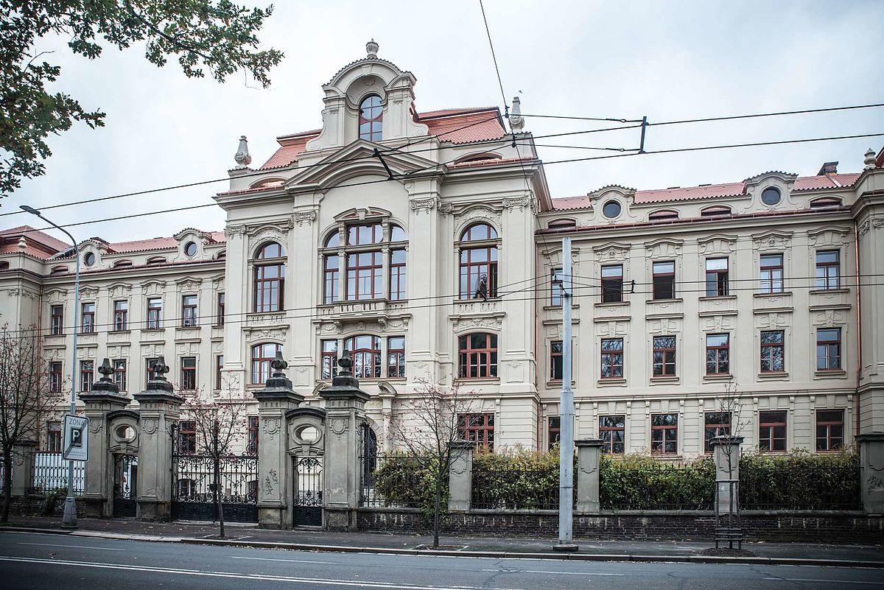
Fig. 2 The title name should begin with a capital letter, centred on the center, ending with a full stop, use the formatting style Juniorstav_Title.
Graphs (Style Juniorstav_SubSection)
Insert graphs to the text as a figure not, not graphs. Insertion requirements are described in chapter Figures. The description of the graph will be, for example, Fig. 2, not Graph 2. All graphs and figures should be cited at the appropriate place in the text.
Bullets (Style Juniorstav_SubSection)
Bullets in the text:
- For writing bulleted lists use formatting style Juniorstav_bullet
Additional text after bullets will be written in the formatting style Juniorstav_BodytextInteded.
Formulas (Style Juniorstav_SubSection)
Formulas should be created in Office Math ML (1) or MS Equation Editor 3.0 (2). If you use Office Math ML, tick the LaTeX format entry in equation editing. The size of the text should match the size of the document text. Each equation will be numbered according to the sequence - the number in brackets at the end of the line. Write the equation into the two-column table. The table will take the full width of the page - the first cell has a column width of 15.3 cm, the second cell has a column width of 0.79 cm. The text will be aligned centre / centre.

$$R_{s}=\prod_{j=1}^{m}{\left[1-\prod_{i=1}^{k}{(1-R_{ji}})\right]}$$ | (1)
 | (2)
where Zx is … after the formula, all variables should be listed in the sentence (not bullets!), including units (e.g. v is the speed in km/h), write the variables mentioned in the text in italics – for writing in italic use the formatting style Juniorstav_Italics, for subscript style Juniorstav_dolní index and for superscript style Juniorstav_horní index.
If a new paragraph begins after the formula, use the formatting style Juniorstav_BodytextIntended for it.
Type characters and spaces (Style Juniorstav_SubSection)
For multiplication do not use character x [eks] or character . (dot), use the math symbol × or · (middle dot). (You can use ASII codes to write these characters: × = Alt+0215, · = Alt+0183). Always use a space (Shift+Ctrl+Space) to separate math symbols from numbers or text, e.g. 105 × 105 mm, or 1 : 2 : 4.
With spaces (Shift+Ctrl+Space) we write characters for addition, subtraction, multiplication and division in mathematical operations and also in the ratio and dimension, eg 3 + 5 - 2 = 6, 20 × 5 = 100, etc.
If the + or - sign shows a positive or negative value for a number, it is adjacent to a number without spaces: +24 ° C, −1 ° C. Without spaces we also write exponents and indices: 5³, 10 − ², n₁, n2…
The marks are separated from the numerical value by a space (Shift+Ctrl+Space), the number and the mark are placed on the same, e.g. 10 ha = 10 hectares, 3 kg = 3 kilograms, 14 % = 14 percent, § 9 = paragraph 9, 100 kWh = 100 kilowatt hours, speed 50 km/h = 50 kilometers per hour, density 5 g.m−³ = 5 grams per cubic meter, temperature 12–15 °C = 12 až 15 degrees Celsius.
If you want to use italics or highlight the text in bold, use the style Juniorstav_italics resp. Juniorstav_bold, but we recommend using as little as possible.
4 DISCUSSION (style juniorstav_section)
It contains interpretation of the results obtained, which should be in the context of other published papers. Answer the questions raised, or comment on hypotheses. All conclusions should be based on the results achieved, i. e interpretation of values from tables, graphs or results of experiments. Discuss any limitations to your research, or speculate about surprising results, especially if they differ from the already published ones.
5 conclusion (style juniorstav_section)
It should contain summary of the main results of the research in the context of the whole issue (area and the previously achieved results).
- The conclusion should be approximately 250 words,
- This is a brief summary of the results achieved,
- It is useful to summarise them like this in highlights,
- It should contain answers to the following questions: Did the results meet your expectations, were the hypotheses confirmed, did you answer all the questions raised?
- How did your research contribute to exploring the issue and knowledge in the area? Etc.
What should the next research steps be? The main findings and results of the research should be reiterated. The conclusion can also serve as a basis for further research.
Acknowledgement (Style Juniorstav_SubSection)
It should contain indication of the source of research funding.
References (Style Juniorstav_SubSection)
- Reference no. 1 (all references according to EN ISO 690)
- References should be listed in the text chronologically (sequentially) [1] [2] [3] …..
- Self-citation maximum 10% of references
- NAYAK, Sumeru a DAS, Sumanta. Spatial damage sensing ability of metallic particulate reinforced cementitious composites: Insights from electrical resistance tomography: Insights from electrical resistance tomography. Materials & Design. 2019, Edition. 175, s. 107817. ISSN 0264-1275. https://doi.org/https://doi.org/10.1016/j.matdes.2019.107817.
- AZHARI, Faezeh a BANTHIA, Nemkumar. Cement-based sensors with carbon fibers and carbon nanotubes for piezoresistive sensing. Cement and Concrete Composites. 2012, Edition 34, n. 7, s. 866-873. ISSN 0958-9465.
https://doi.org/https://doi.org/10.1016/j.cemconcomp.2012.04.007.

